Evidence for Implementation and Testing Unit.

Pauline Cairns

E21

I.T 1- Demonstrate one example of encapsulation that you have written in a program.

Fruit Machine project

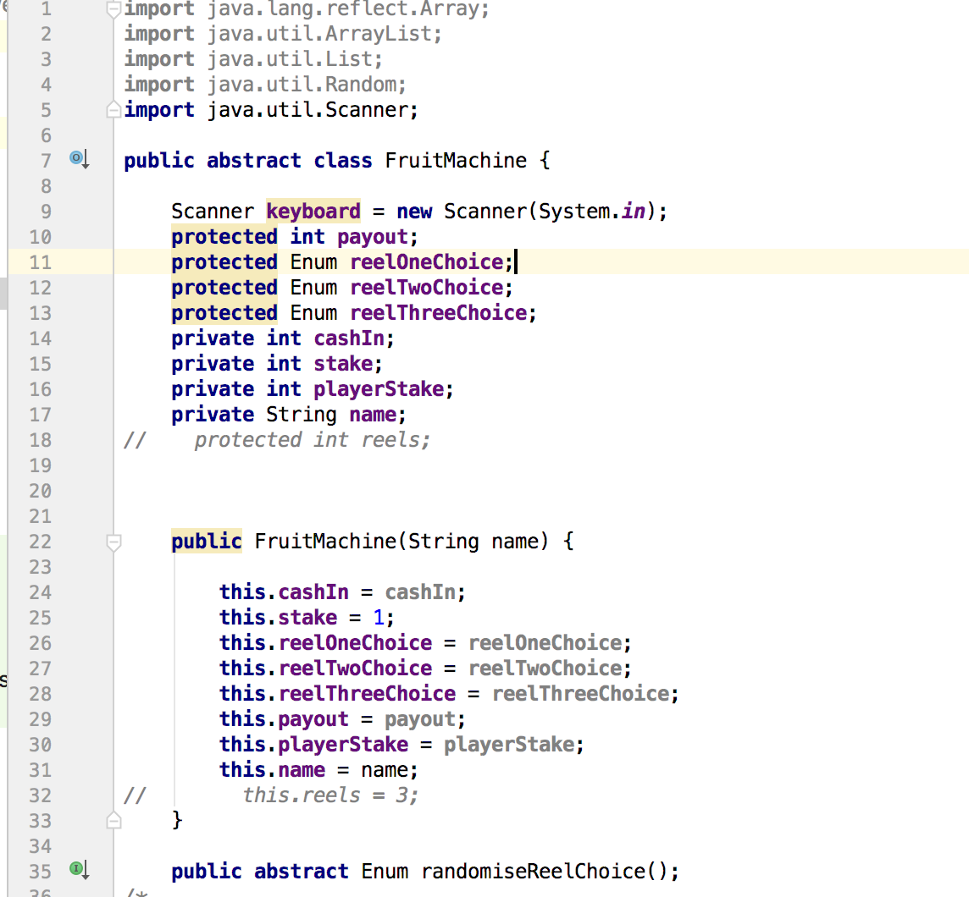

I.T 2 - Example the use of inheritance in a program.



Evidence for unit

I.T 3 - Example of searching

(if you do not have a search and sort algorithm, write one up, take a screenshot. Remember to include the results as well)

I.T 3 - Example of searching

(if you do not have a search and sort algorithm, write one up, take a screenshot. Remember to include the results as well)

From film.rb in Cinema weekend 3 homework

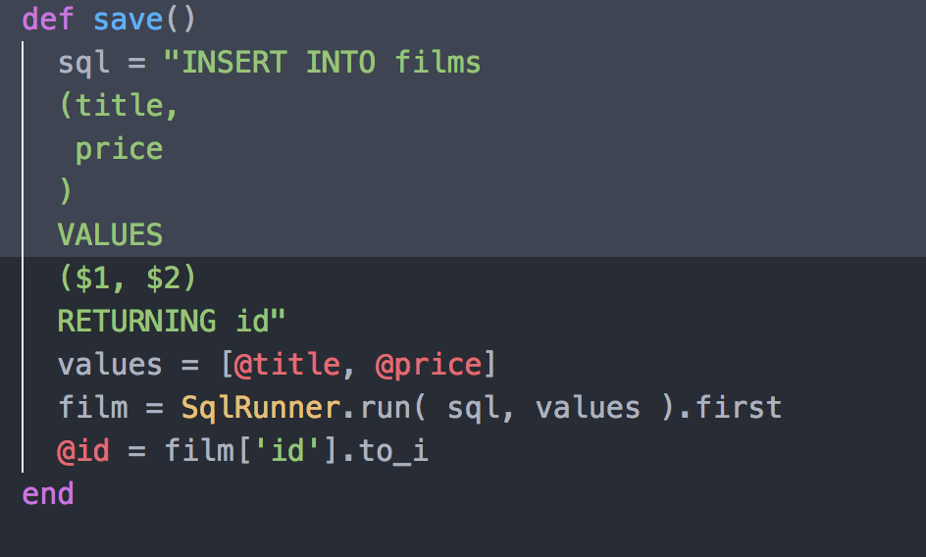

How many people watching one film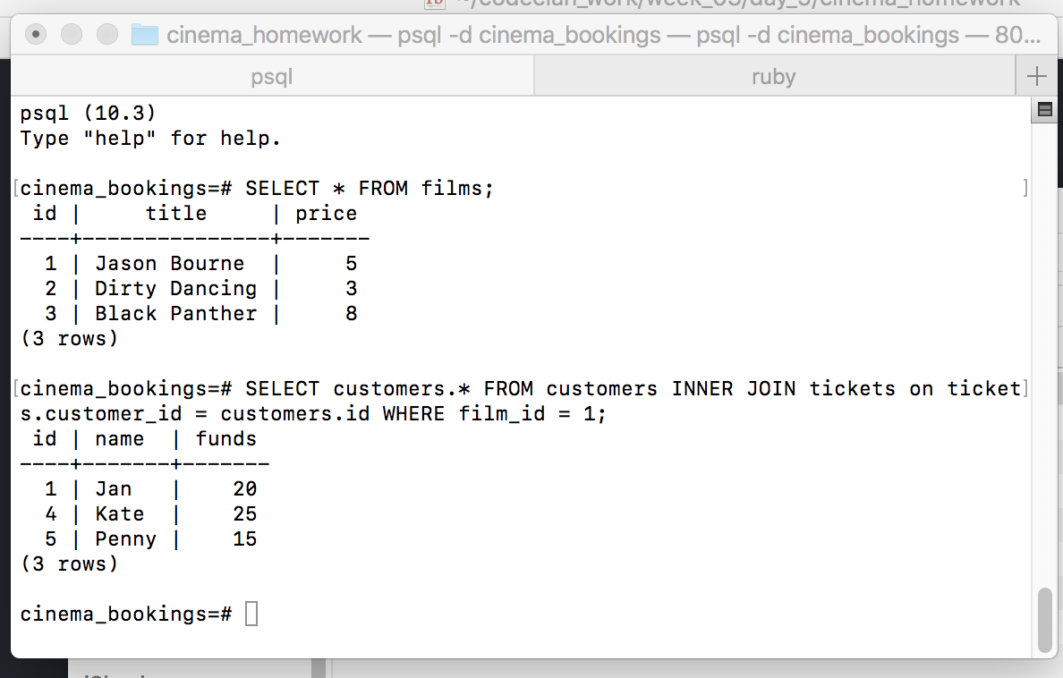

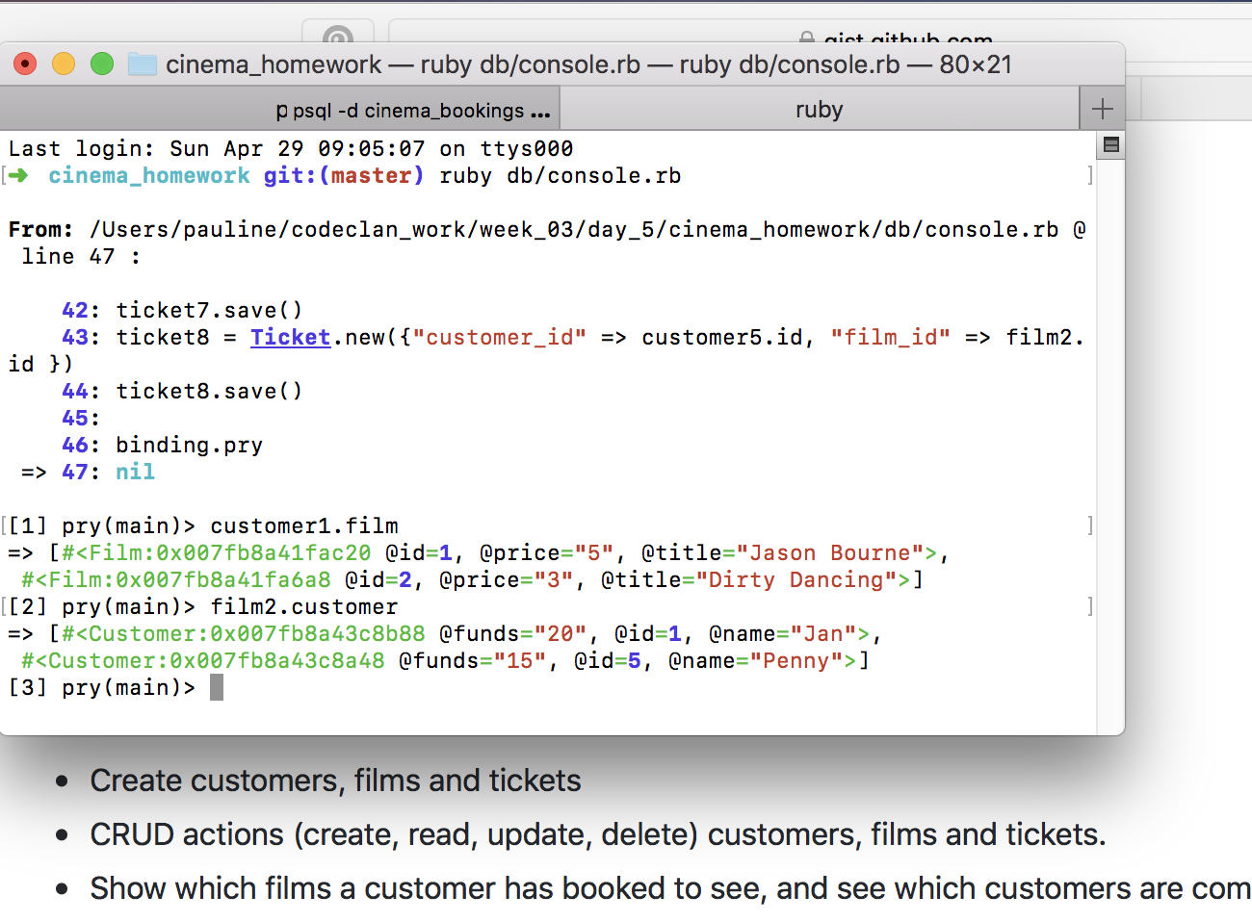Check in pry

I.T 4 – Example of sorting



Evidence for unit

I.T 5 - Example of an array, a function that uses an array and the result



Evidence for unit

I.T 6 - Example of a hash, a function that uses a hash and the result



Evidence for unit

I.T 7 - Example of polymorphism in a program



Evidence for unit